**Software Engineering 412 Group SPMP:**

**Part 0: Front Matter**

**0.1 TITLE PAGE:** Education Game Group Project

**0.2 REVISION SHEET:**

**(Table 0.3)**

|  |  |
| --- | --- |
| **Date** | **Revision Made** |
| 2/25/2020 | Changed game plan from snake to 24. |
| 2/25/2020 | Uploaded SPMP |

**0.4 PREFACE:** Scope - It will reach out to students of a young age as well as their parents. The purpose is to create a fun math learning game for children.

**Table of contents:**

Part 0 - Front matter

0.1 Title Page

0.2 Revision Sheet

0.4 Preface

Part 1 - Introduction

1.1 Project Overview

1.2 Project Deliverables

1.3 Evolution of the SPMP

1.4 Reference Materials

1.5 Definitions and Acronyms

Part 2 - Project Organization

2.1 Process Model

2.2 Organizational Structure

2.3 Organizational Interfaces

2.4 Project Responsibilities

Part 3 - Managerial Process

3.1 Management Objectives and Priorities

3.2 Assumptions, Dependencies, and Constraints

3.3 Risk Management

3.4 Staffing Plan

3.5 Monitoring and Controlling Mechanisms

Part 4 - Technical Process

4.1 Methods Tools and Techniques

4.2 Software Documentation

4.3 Project Support Functions

Part 5 - Work Elements, Schedule, Budget

5.1 WBS

5.2 GANTT Schedule

5.3 Budget

**Figures and Tables:**

Part 0:

Table 0.3

Part 1:

Part 2:

Figure 2.2

Part 3:

Part 4:

Table 4.4

Part 5:

Figure 5.1

Figure 5.2

**Part 1: Introduction**

**1.1 Project Overview**

**Executive summary: description of project, product summary**

→ Using Python and the Flask framework to create a web-enabled replication of the educational arithmetic card game, “24”. The game will feature buttons for each of the 4 numbers displayed to the screen, as well as sidebar buttons for each of the available operands (plus, minus, multiply, and divide). The game will also include a scoring/leaderboard mechanism to keep track of each individual's time when completing each round. This feature encourages the player to continuously improve and promote healthy competition. The product will assist younger students to compute basic mathematical expressions, while presenting an inviting web-interface to learn.

**1.2 Project Deliverables**

**All items to be delivered, including delivery dates and location**

1. February 21st, 2019 - Virtual Classroom
   1. Github Repository Creation
      1. Addition of members, including Professor Broadwater
   2. Communication channels established
      1. Google Drive
      2. SMS Contact Exchange
2. February 25th, 2019 - YR128 Classroom
   1. SPMP Submission
3. …
4. Demo of Website “Skeleton”, Halfway through semester - YR128 Classroom
   1. Establishment of overall function
      1. Game function
      2. Leaderboard
5. …
6. Final delivery of Project Prototype, End of semester -YR128 Classroom
7. …
8. Final Installation of product

**1.3 Evolution of the SPMP**

**Plans for anticipated and unanticipated change**

**→ Anticipated:** Different areas of the project plan can be compressed if shortcomings arise. Should problems arise before or during the Design stage, we can compress and overhaul the System Design process to make up for lost time, while still staying on schedule for the other parts of the project plan. This goes for the Software section of the Installment stage as well. Should the need arise, the section may be compressed and the installation of the service can be overhauled.

→ **Unanticipated:** Should redesign issues arise where time becomes evermore pressing, a redistribution of labor may be in order to resolve the conflict. Thus requests can be made to other teams to assist with the different parts of the project. For example, should the entire Front-End of the application need a redesign due to unforeseen functional issues, the Server team can lend a hand in conjunction with the Design Team to get the ball rolling as quickly as possible.

**1.4 Reference Materials**

**Complete list of materials referenced in SPMP**

* **Example 24 WebApplication:** [**https://www.4nums.com/**](https://www.4nums.com/)
* **24 Game Info:** [**https://www.24game.com/**](https://www.24game.com/)
* **Flask Tutorial:** [**https://www.youtube.com/watch?v=lj4I_CvBnt0**](https://www.youtube.com/watch?v=lj4I_CvBnt0)
* **Flask General Info:** [**https://en.wikipedia.org/wiki/Flask_(web_framework)**](https://en.wikipedia.org/wiki/Flask_(web_framework))

**1.5 Definitions and Acronyms**

* **24** is a well known math card game where players attempt to reach 24 with a limited set of numbers as fast as possible using different operands. The game has been used to teach arithmetic to students throughment the modern era.
* **Flask** is a micro web framework written in Python. It is classified as a microframework because it does not require particular tools or libraries. It has no database abstraction layer, form validation, or any other components where pre-existing third-party libraries provide common functions (2020, Wikipedia)

**Part 2: Project Organization**

2.1 Process Model:

* Client interacts with the game, has read-only access to the leaderboard, and is able to log onto an account through a backend server.
* The game will update the leaderboard through the backend server

2.2 Organizational Structure: (Figure 2.2)



2.3 Organizational Interfaces:

* Use Python/Flask to code the game
* Use Digital Ocean for server development

2.4 Project responsibilities:

*Major functions and activities; nature of each; who’s in charge*

*Matrix of project functions/activities vs. responsible individuals*

The Game:

* Will be created using the flask framework on python.
* On screen, there will be 4 numbers and various arithmetic operations.
* Each item will be drag-and-droppable into boxes, alternating between number and operation, in order to create a combination that equals 24.
* The game will be timed over multiple rounds and keep track of accuracy to generate a score to upload to the leaderboard.
* The game development team will be in charge of creating the game.

The Server:

* Will be created using Digital Ocean.
* Will host the leaderboards to view everyone’s scores.
* Handles domain and DNS configuration.
* Provides a database for client accounts.

**Part 3: Managerial Process**

**3.1: Management Objectives and Priorities**

* The objectives that this group will prioritize will be the single player, multiplayer, and team experiences. As well as the facilitation of advertisement revenue in addition to donations from appropriate venues.
* The schedule for this project aligns with the weekly deliverables as well as the dates set in the syllabus for this class.
* The budget for this project has yet to be determined at the current time, once we have chosen our web services we will be able to establish that.

**3.2 Assumptions, Dependencies, and Constraints**

* This project depends on no outside events.
* The constraints we are working under would be time, the due dates for the deliverables.

**3.3 Risk factors**

Size of Project:If the project becomes too large we will reassess everyone’s assigned tasks and eliminate all non-essential ones.

Complexity of Project: If the project becomes too complex later down the road of the development cycle we will have to simplify the tasks given to us.

Staff: If someone left the project we would have to redistribute their assigned tasks to the existing members of the team adding more work to their load.

Client Acceptance: If the client doesn't like our proto-type then we will get a list from them about the aspects of our proto-type that they are not happy with, and then work to resolve each point on the list.

**3.4 Staffing Plan**

Our project will consist of five team members. One person handling the design of the end product. They are responsible for making everything visually appealing. Two team members will be responsible for the development of the actual game. They will handle the actual programming. And the last two team members will be responsible for the servers, leaderboards, and uploads.

**3.5 Monitoring and Controlling Mechanisms**

We will be using Github to monitor the progress of the project. We have a schedule established and when we update our part of the project we will make it known to the other members of the group.

**Part 4: Technical Process**

**4.1 Methods, Tools and Techniques:**

We will use cloud networks including google docs and github to exercise group collaboration, allowing the entire group to simultaneously work on the same or seperate elements of the project at once. Tools used will include Python, Flask and Wordpress. Techniques used by the team will include problem solving skills, time management skills, conflict resolution, and risk management.

**4.2 Software Documentation:**

For Software Documentation, Github Version Control will be used to maintain access to every version of the project as it is developed. If any major mistakes are made, an older version can be recovered to fix the mistake.

**4.3 Project Support Functions:**

To ensure quality assurance, a reliable server host will be purchased from. The current plan for the server host is name.com, due to the website having a good reputation while still being affordable. The website will be tested once it is up, and the game code will be tested during development. The Configuration Management Plan is to use GitHubs Version Control in order to ensure reliable CM so that no work is lost.

**Verification and Validation Plan(Table 4.4)**

|  |  |
| --- | --- |
| **User Requirements** | **Method to Meet Requirements** |
| Educates users on a healthy lifestyle | Game will be based on math, so that users work on math skills by playing |
| Singleplayer, team, and multiplayer modes | Website and Server will allow “rooms” where multiple users can interact, along with multiplayer game code added into the project |
| Advertising and Donations | Ads will be placed on the edges of the screen, allowing users to see them |
| Parents can monitor child | Account creation allows a user to create a “parent account” which can then create “child accounts” that belong to the parent account. This way, a parent can make an account for their child and give them the username and password. A parent account will be able to monitor the progress of any of its child accounts. |
| Government can contribute and monitor | Government officials have access to “government accounts” which allow monitoring of the progress of all users. |

**Part 5: Work Elements, Schedule, Budget**

**5.1 WBS**

(figure 5.1)

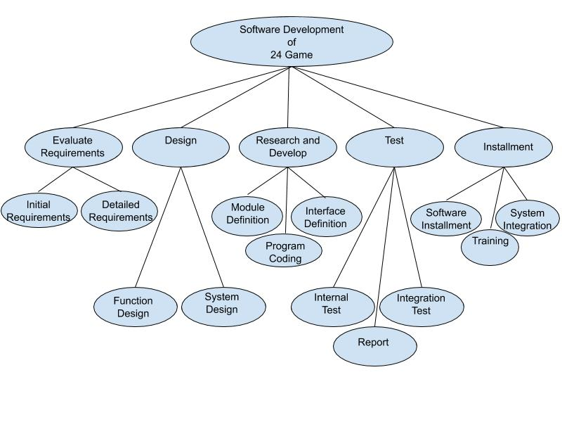

**5.2 GANTT SCHEDULE**

(figure 5.2)

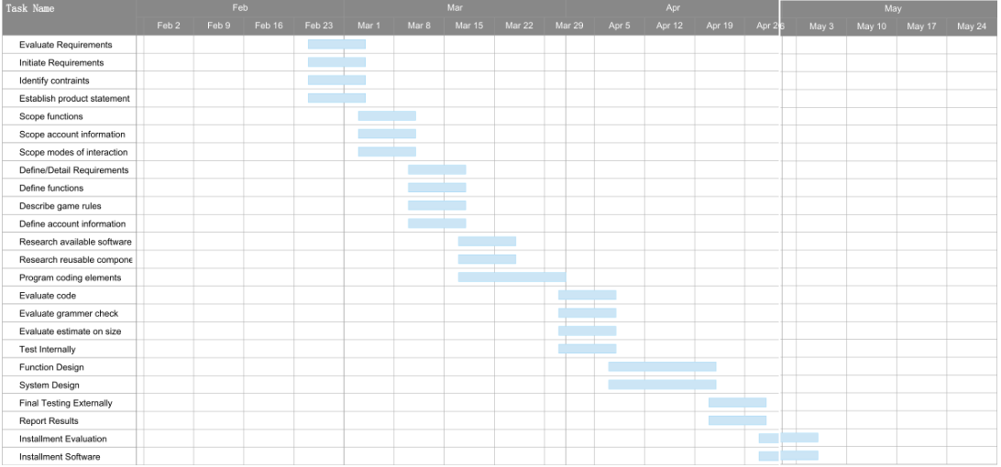

**5.3 BUDGET**

TBD